**Homework 10**

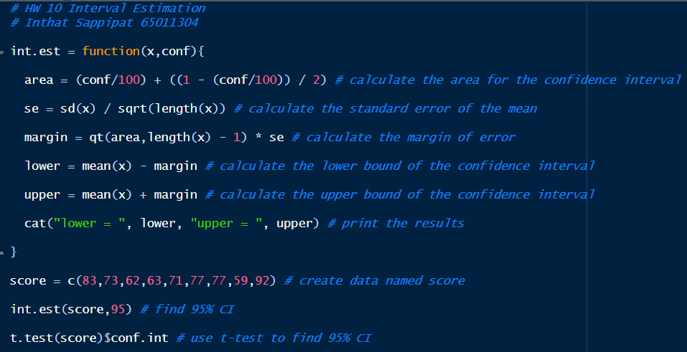**Code:**

**Result:**



**Conclusion:**

From the experiment, I created a custom function named int.est to calculate a 95% confidence interval. Also, I used a t-test to calculate a 95% confidence interval using the formula t.test(score)$conf.int. The custom function prints the lower and upper bound and the t-test gives a similar result. In my opinion, the custom function int.est and t-test both give the confidence interval for the mean of the dataset, and these two methods give the similar results.